Practical no.5
array
Input:
#include <iostream>
#include <string>
using namespace std;

class ArrayStack {
private:
string pages[MAX];
int top;

public:
ArrayStack() {
top = -1;
}
bool isEmpty() {
return top == -1;
}
bool isFull() {
return top == MAX - 1;
}
void push(string page) {
if (isFull()) {
cout << "Stack Overflow!\n";
return;
}
pages[++top] = page;
}

string pop() {
if (isEmpty()) {
return "Stack Underflow";
}
return pages[top--];
}

string peek() {
if (isEmpty()) {
return "";
}

return pages[top];
}
};

int main() {
ArrayStack backStack;

string currentPage = "Home";
cout << "Visiting: " << currentPage << endl;

backStack.push(currentPage);
currentPage = "Google";
cout << "Visiting: " << currentPage << endl;

backStack.push(currentPage);
currentPage = "YouTube";
cout << "Visiting: " << currentPage << endl;

backStack.push(currentPage);
currentPage = "Wikipedia";
cout << "Visiting: " << currentPage << endl;
cout << "\nBack button pressed.\n";

currentPage = backStack.pop();

if (!currentPage.empty()) {
currentPage = backStack.peek();
cout << "Current page: " << currentPage << endl;
}

cout << "\nBack button pressed.\n";

currentPage = backStack.pop();

if (!currentPage.empty()) {
cout << "Current page: " << currentPage << endl;
}

return 0;
}
Output:
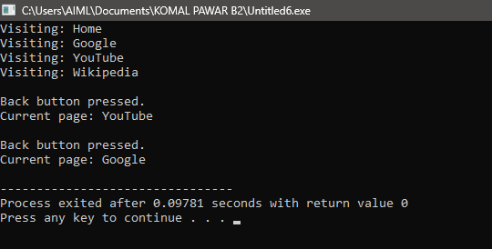
5.2:linked list
Input:
#include <iostream>
#include <string>
using namespace std;
struct Node {
string page;
Node* next;
Node(string p) {
page = p;
next = NULL;
}
};
class LinkedStack {
private:
Node* top;
public:
LinkedStack() {
top = NULL;
}
bool isEmpty() {
return top == NULL;
}

void push(string page) {
Node* newNode = new Node(page);

newNode->next = top;
top = newNode;
}

string pop() {
if (isEmpty()) {
return "";
}

Node* temp = top;
string page = top->page;

top = top->next;
delete temp;

return page;
}

string peek() {
if (isEmpty()) {
return "";
}

return top->page;
}

~LinkedStack() {
while (!isEmpty()) {
pop();
}
}
};

int main() {
LinkedStack backStack;
string currentPage = "Home";
cout << "Visiting: " << currentPage << endl;

backStack.push(currentPage);
currentPage = "Google";
cout << "Visiting: " << currentPage << endl;

backStack.push(currentPage);
currentPage = "YouTube";
cout << "Visiting: " << currentPage << endl;

backStack.push(currentPage);
currentPage = "Wikipedia";
cout << "Visiting: " << currentPage << endl;
cout << "\nBack button pressed.\n";
currentPage = backStack.pop();
cout << "Going back to: " << currentPage << endl;
cout << "\nBack button pressed.\n";

currentPage = backStack.pop();
cout << "Going back to: " << currentPage << endl;
return 0;
}

Output:
